**ASSignment Report**

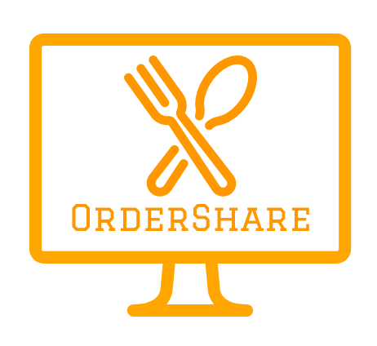

Monika Biniewicz, Emilia Chmielowska, Tautvydas Cerniauskas, Stefan Rudvin

Introduction

Competition in food ordering applications segment is very high, as there is plenty of different platforms from which customer can choose from. Few of them offer a group ordering feature, for example Seamless or Grubhub. However, they are only available for corporate use and only make it easier to split the bill between people who know each other.

Serving as a logistics platform, OrderShare aims to allow its users to save money through the use of economies of scale enabled by group orders. The users of the service not only benefit from the lower cost of delivery, but are also able to make use of various deals offered by restaurants. Taking a popular pizza restaurant chains as an example, Domino’s Pizza offers 25% off a £20 purchase or 50% off on a £100 order. Our service allows customers to discover current restaurant menus and deals and make a private or public group order. A public order entails that a user picks a few deals they are interested in, specifies the maximum number of people they would like to join their order, and users nearby are notified about the order being created and encouraged to join. After the order is complete and the total amount qualifies for one of the chosen deals, the service sends it to the chosen venues, splits the payment between the users applying appropriate discounts, and charges the users the corresponding amounts using their provided card details. A private order follows the same process, but it lets the user add their friends to the order, making it closed to the public. Furthermore, ordering from different restaurants at the same time will not be a hassle, as our app will split the payment accordingly and the appropriate sum will be paid to each restaurant. As we will not initially have a delivery system, the orders will be delivered separately. However, each restaurant will be notified to deliver at a certain time so that orders arrive together. In the future, we will offer inter-restaurant deals and our own delivery service.

Concept formation

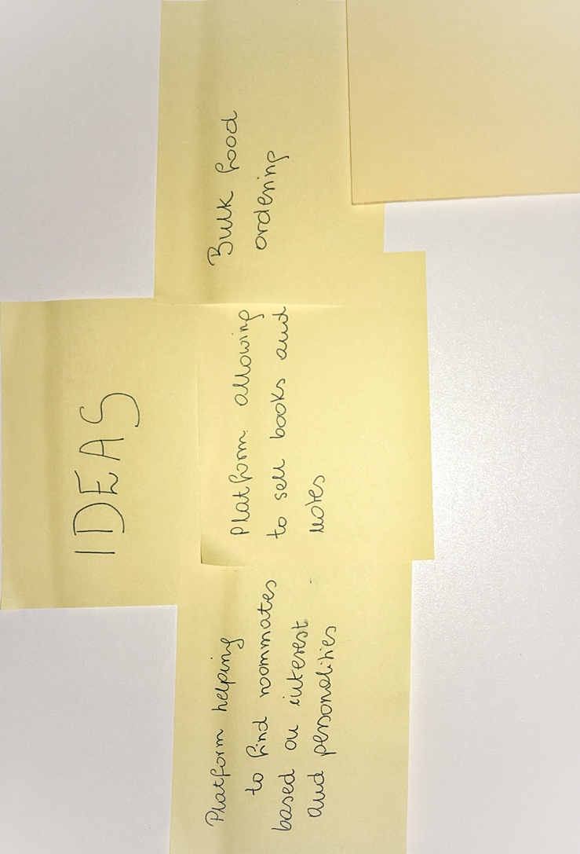

Figure Ideas

Initially, we created a list of three ideas for a service. They were:

* a platform which would recommend flatmates based on users' profiles
* a marketplace-like app for university students, where they could sell and exchange their books and notes
* a bulk food ordering service

The research was conducted on the latter. We identified issues connected to services available based on our own experience, but also knowledge taken from news. Because restaurants often charge high delivery fees or offer deals hard to achieve by a single person, customers are likely to order more than they actually are able to consume, which causes them to either overeat or waste food.  According to NHS (2015) one in four British adults is obese and more than 40% is overweight, putting UK in the first place in the entire Europe. A lot of blame should be linked to take away food and portions people consume. Secondly, £13 billion worth of food is thrown away every year by UK households. Furthermore, group ordering would allow restaurants to send one delivery with an order for multiple people, reducing fuel costs and emission of fumes into the environment. As this concept creates value both for customers, society as a whole and the environment, we have decided to explore the idea of the group ordering further.

THE HAPPY STARTUP CANVAS

This canvas explains our business idea and how to make our customers happy with the service.

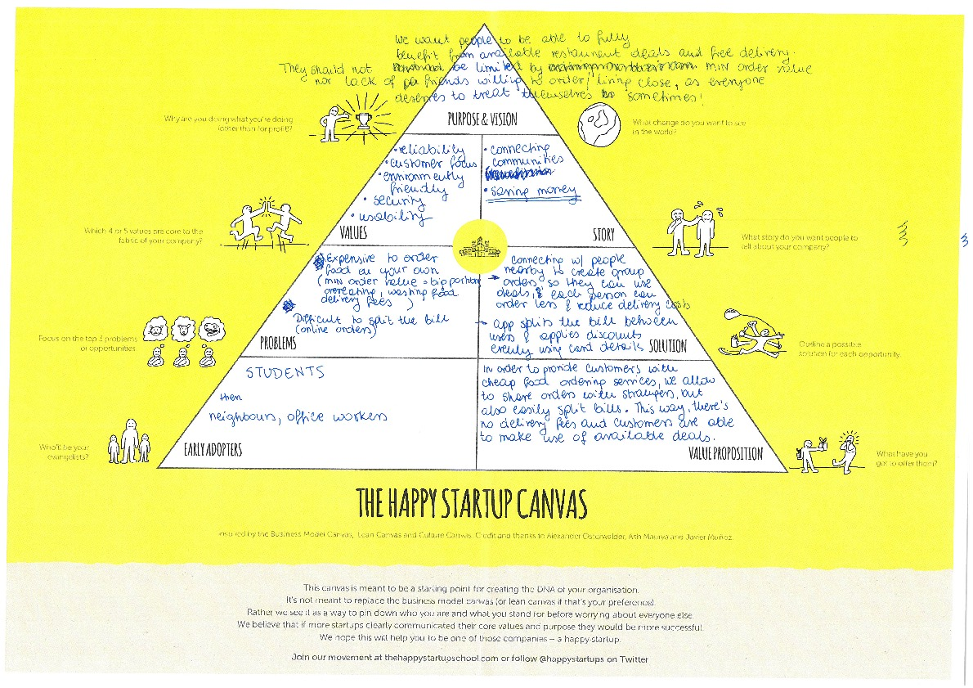

Figure draft of the happy startup canvas

Purpose and vision - what are our goals?

We want people to be able to fully benefit from deals available in restaurants and free delivery whether they order with strangers or friends. The goal is to save money, reduce food waste in case people order more than they want to reach minimum order value, help fight obesity and increase eco friendliness by sending orders to multiple people in one delivery.

Values - what do we care about?

* reliability - orders should be delivered within the time limit,
* customer focus - customers are the core of our business and they should be happy
* security - personal data is safe and card payments are executed through reliable services
* usability - the app should be easy to use

Story - how we want to be perceived

People should tell their friends how easy it is to save money with our app and order without any problems.

Problems - what issues do our customers have that we can solve?

* It is expensive to order food on your own. The minimum order value forces customers to order more than they want, resulting in overeating, wasting food and money or it forces customers to pay high delivery fees which pollutes the environment with small deliveries.
* While ordering with friends it is difficult to split the bill

Solution - how we create value for our customers

* App should connect strangers to order "together" from the same restaurant, so they can benefit from deals, free delivery and ordering smaller portions.
* App should split the bill between users and apply discounts evenly to everyone, so each person can pay by card for their order

Early Adopters - target group that would be the first to use it

Students should be the first ones to start using the app, as they are technology literate, often live in the same neighbourhoods/student halls and are keen to order take away.

Once the business gains popularity, people living in the same neighbourhoods or office workers could order together.

Value Proposition - how do we differentiate from competitors?

There is plenty of food ordering apps available, but we are different. In order to provide customers with cheap food ordering services we connect orders of strangers and easily split the bill and discounts between them. As private ordering group can be also created, it is possible to order with friends and not worry about the money. This way there is no delivery fee and customers are able to make use of available deals, while ordering just as much as they want, despite the minimum order value. It reduces food waste and overeating, but still allows customers to treat themselves.

Overview of benefits of customer data

As it was previously mentioned OrderShare is a small start-up business company. Taking that into consideration, we will be quite limited to the amount of customer data we receive. In the earlier stages of a company our main goals will be to: analyse our user-base, work-out how often user tend to use our system, their occupation and age.

In the later stages of the business our focus shifts from collecting data locally to, implementing different type of authentication such as, Facebook Auth. Implementation of such technology will allow us to take an advantage of Facebook API provided information such as: user liked restaurants, their most visited food places, and other similar information. Furthermore, our plan is to have our own Facebook page, which allow users to leave direct reviews about our services.

More information can be found in the Customer Data file.

Target Market Segments and Personas

For the purpose of better identification of the goals of OrderShare we have identified four main customer segments:

* University students in the age of 18 to 24 living in student halls
* Office workers ordering lunch to their offices
* Young adults in the age of 25-34 who live in their own or shared flats
* Families who order from more than one restaurant at a time and wish to complete and pay for all the orders simultaneously

In order to better visualise our customer segments, we have created four personas representing each one of them, which are available in the file personas.pdf.

For each of our personas we have also created a corresponding empathy map and value proposition canvas. These artefacts have helped us identify the main pains and gains of our personas and the gain creators and pain relievers our service provides.

Some of the common pains of our personas

* Low variety of food providers in the area
* Inability to split the bill when ordering food with friends
* High food delivery prices
* High minimum order amounts
* Lack of time or ability to cook
* Excessive spending on take-away food
* Lack of time to check separate restaurant menus and deals
* Time-consuming process of ordering food from a few restaurants at a time
* Not having friends to order food with

Some of the common gains expected by our personas

* Keep within the budget
* Discover best deals
* High variety of meals choices
* Easy payment process allowing to split it between friends or pay for the whole order
* Save time
* Be able to complete an order in a few restaurants quickly
* Find a way to qualify for available deals

The offered functionalities that reduce pains and increase gains

* No delivery fees with group orders
* Delivery to areas outside of city centre due to group orders
* All restaurant menus and deals combined in one place
* Easy payment system allowing users to split the payment or for one user to pay for the whole order
* Partnerships with many restaurants allowing for more choice
* Private group orders created with friends
* Recommendations of affordable restaurants nearby and best achievable deals
* Mixed orders enabling ordering and paying in different restaurants at the same time
* Notifications about public orders created nearby
* Delivery to the agreed pick-up point

references

NHS. (2015). Britain. The Fat Man of Europe. Retrieved from https://www.nhs.uk/Livewell/loseweight/Pages/statistics-and-causes-of-the-obesity-epidemic-in-the-UK.aspx [Accessed on 23 February 2018]

Smithers, R. (2017). UK throwing away £13bn of food each year, latest figures show. Retrieved from https://www.theguardian.com/environment/2017/jan/10/uk-throwing-away-13bn-of-food-each-year-latest-figures-show [Accessed on 23 February 2018]

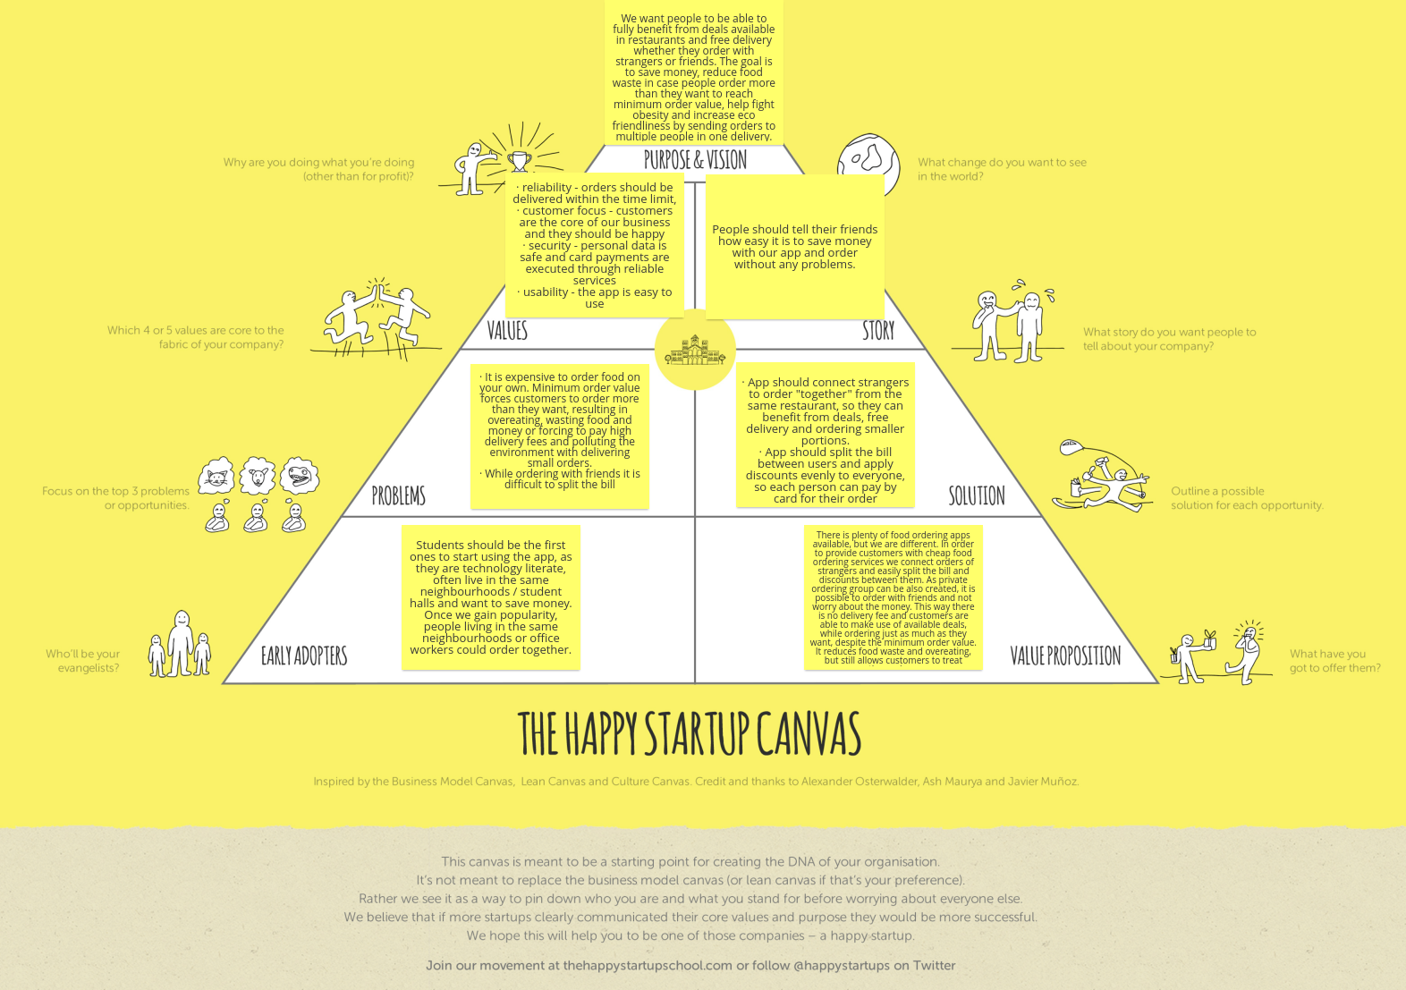

Figure the happy startup canvas